|  |  |
| --- | --- |
| Payload analysis@Eaton |  |
| QXtend |

1/16/2017

Regoti, Sujata

@Eaton

QXtend

1. From payload get end point

<qcom:propertyName>**EndpointURI**</qcom:propertyName>

<qcom:propertyValue> **http://ascqa.tcc.etn.com:8081/asc1qxi163/services/QdocWebService**</qcom:propertyValue>

In the above endpoint URI, asc1qx**i**163represents asc1 QXtend Inbound. For outbound : asc1qxo163

Use Link : http://ascqa.tcc.etn.com:8081/asc1qxi163

1. Get wsaTo Property

<ns2:propertyName>wsaTo</ns2:propertyName>

<ns2:propertyValue urn:services-qad-com:aspgqueryqxi</ns2:propertyValue>

Here outbound receiver aspgqueryqxi.

1. Open above URI. Go to Configuration->Receivers->Outbound

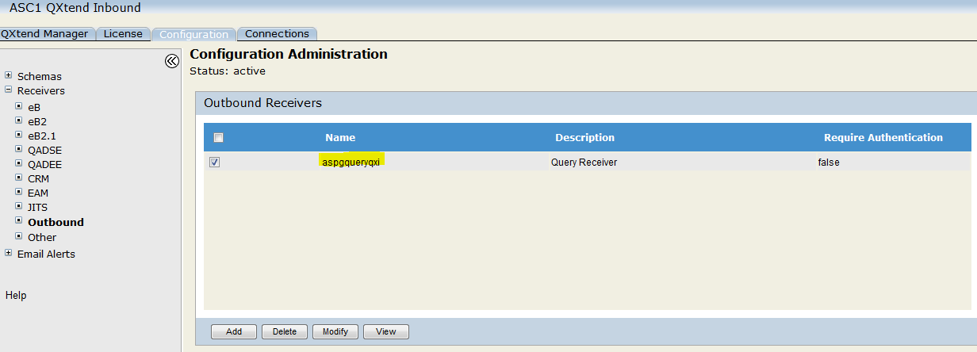

Under receivers find above receiver name.

We can check whether receiver specified in payload is available in Outbound Receiver list or not.

1. If found, Click on View.

<part name="body">

<queryXxMasterComments> 🡪 Receiver QDocName

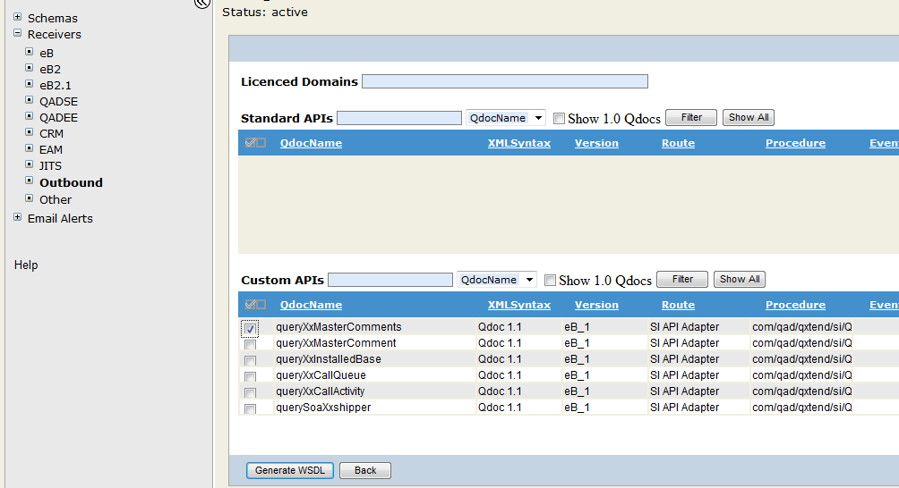

Check Version as specified in payload.

<ns2:propertyName>version</ns2:propertyName>

<ns2:propertyValue>**eB_1**</ns2:propertyValue>

1. In outbound, Under Business Object find response provided in payload.

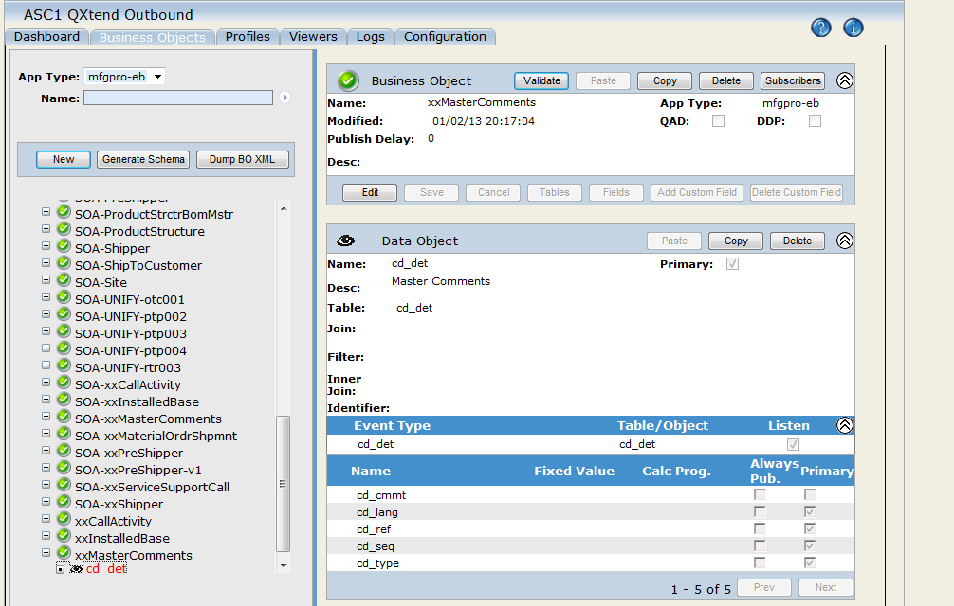

Under Business Object, we get Table and All its fields details.

Regoti, Sujata

WCE, Sangli Intern@Eaton

@Eaton